Hands-on :
Spring REST using Spring Boot 3 - RESTful Web Services

Exercise 1:
Hello World RESTful Web Service
Project Structure :
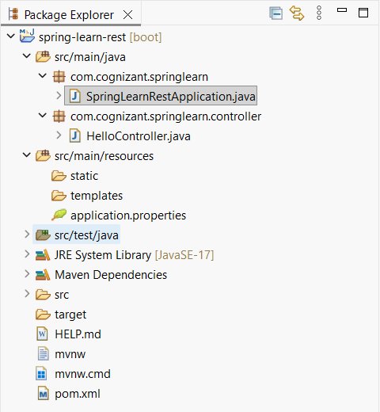

Spring Boot Main Class :
@SpringBootApplication
public class SpringLearnRestApplication {
public static void main(String[] args) {
SpringApplication.run(SpringLearnRestApplication.class, args);
}
}

File name : HelloController.java
@RestController
public class HelloController {

private static final Logger LOGGER =
LoggerFactory.getLogger(HelloController.class);

@GetMapping("/hello")
public String sayHello() {

LOGGER.info("START");

String message = "Hello World!!";

LOGGER.info("END");

return message;
}
}

File name : application.properties
spring.application.name=spring-learn-rest
server.port=8083

Browser Output :
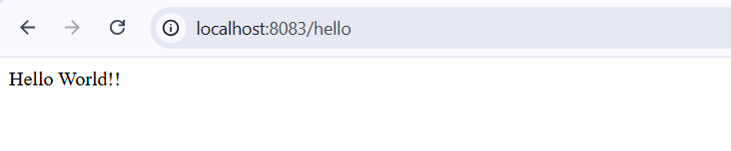
Console Output :
